Home Page
- When the user clicks the button, a live image should immediately appear in a pop-up. The image should be generated in real time and displayed instantly.
- ERGON Foundation - Font to be changed
- Logo is not visible
- Footer – People, Pets, People - Not found anywhere in the website.

About

- Animal welfare related impact numbers to be added in the below banner.

Alignment to be checked – ( In about & Our Causes page )
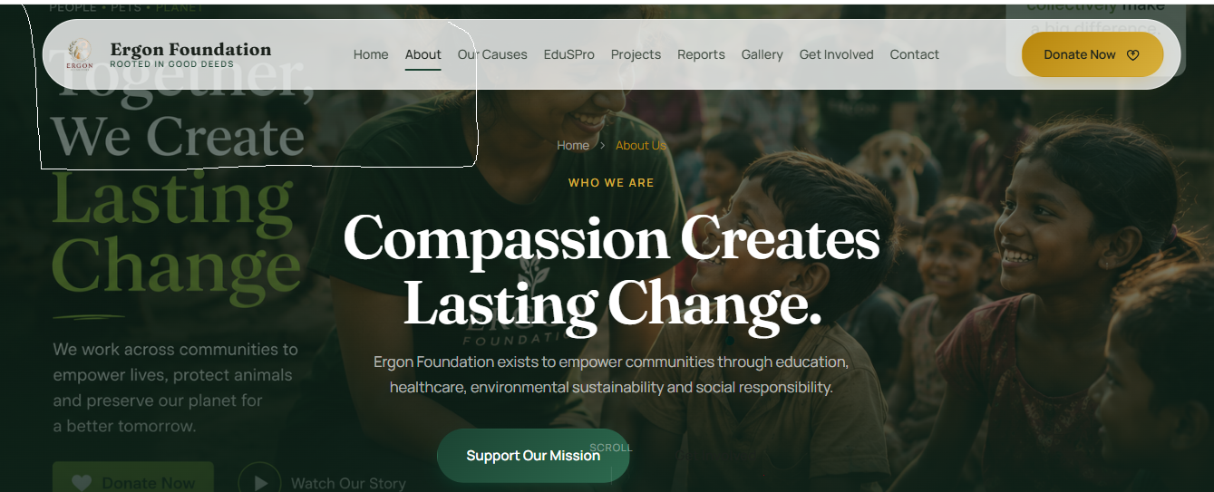
Vision & Mission statements to be reviewed.
Vision : The vision of ERGON Foundation is to work for the welfare of People, Pets, and the Planet through charitable and sustainable initiatives. The Foundation is committed to supporting poor and needy communities, caring for animals, and protecting the environment in Tamil Nadu and across India.

Our Journey
How We Started and Where We're Going - Changes to be done – Realistic data to be filled in
ERGON Team
ERGON Patrons – Create and keep it blank to be filled in later
ERGON Staff
- Remove Sangeetha’s designation (Keep it blank)
Our Partners & Donors – Respective LOGOS to be added
EduSpro Details to be reviewed

